# TITLE:

# Contributions of human activities to suspended sediment yield during storm events from a steep, small, tropical watershed

SSYEV, m3, km2, SSYUPPER, SSYLOWER, SSYTOTAL, SSYPRE, SSYFOREST, SSYVILLAGE, SSYQUARRY, alpha, Beta

## ABSTRACT

Abstract text goes here....

## Introduction

## Study Area



Figure 1. Faga'alu watershed showing the Uupper (undisturbed) and Lower (human-disturbed) subwatersheds.

## Methods

## Results and Discussion

### Field Data Collection

#### Suspended Sediment Concentration

From October 1, 2014, to January 9, 2015, 418 samples were collected in Faga'alu and analyzed for SSC. Three sites were the focus of this analysis: 1) FOREST(n=17), 2) QUARRY (n=16 grab samples, n=192 from the Autosampler), and 3) VILLAGE (n=33). Mean SSC of grab samples collected during baseflow and stormflow were 47 mg/L at the FOREST site, 219 mg/L at the QUARRY, and 24 mg/L the downstream VILLAGE site. Maximum SSC values were 236 mg/L, 1,837 mg/L, and 194 mg/L at the upstream (FOREST), quarry (QUARRY), and downstream (VILLAGE) sites, respectively. The maximum SSC value at QUARRY (1,837 mg/L ) was sampled on 11/03/2014 at 96 L/sec. The maximum SSC value at VILLAGE (194 mg/L) was sampled on 11/03/2014, when discharge was 2,288 L/sec. The maximum SSC value for the upstream site (236 mg/L) was sampled on 01/09/2015 at discharge 888 L/sec.

At FOREST, 13 grab samples (0%) were taken during stormflow conditions (Q_DAM>165 L/sec), with mean SSC of 61 mg/L. At QUARRY, 10 grab samples (0%) were taken during stormflow conditions (Q_DAM>165 L/sec), with mean SSC of 67 mg/L. At VILLAGE, 19 samples (0%) were taken during stormflow conditions (Q_VILLAGE>364 L/sec), with mean SSC of 32 mg/L (Figure 5). This pattern of SSC values suggests that little sediment is contributed from the forest upstream of FOREST, then there is a large input of sediment between FOREST and QUARRY, and then SSC is diluted by addition of stormflow with lower SSC between QUARRY and VILLAGE.

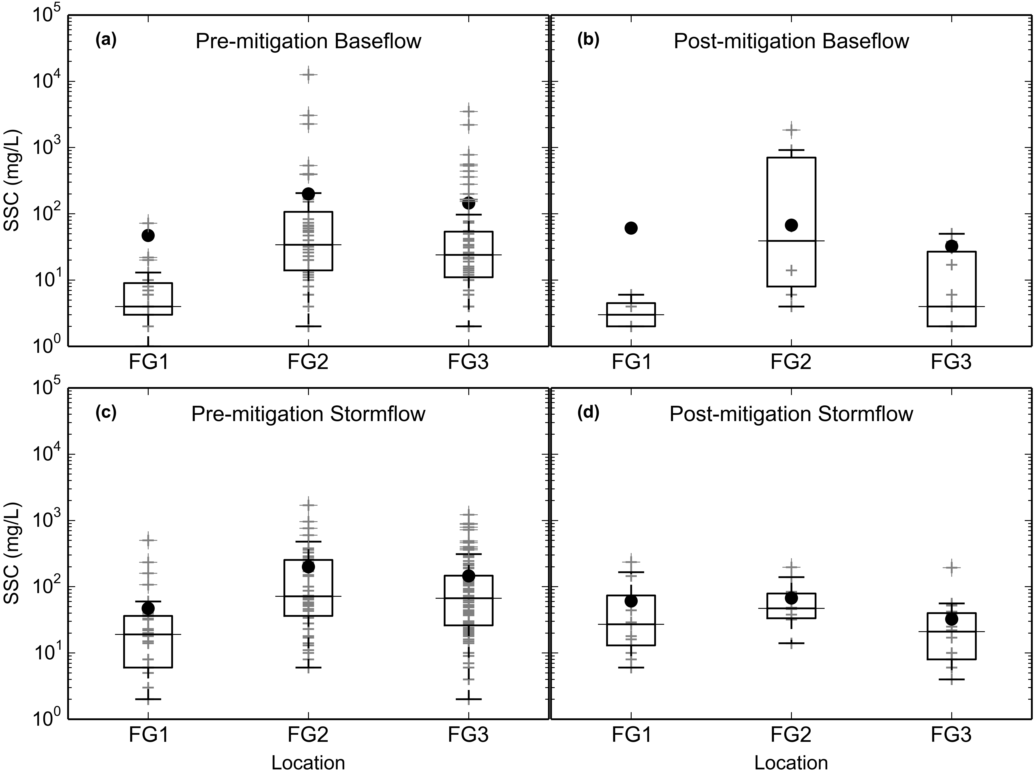

Figure 5. Boxplots of Suspended Sediment Concentration (SSC) from grab samples only (no Autosampler) at FOREST, QUARRY, and VILLAGE during storm periods.

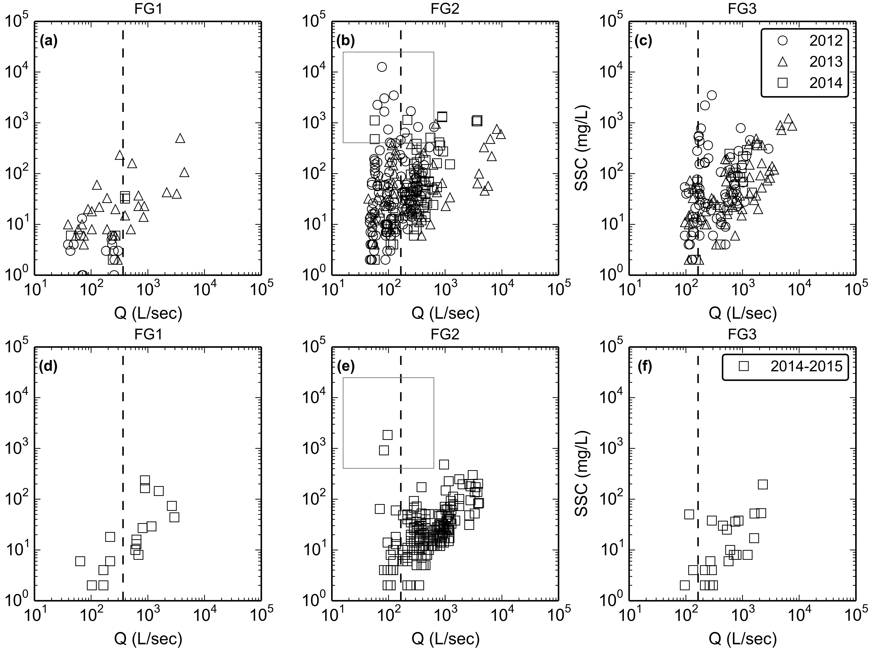

Figure 5. Water Discharge vs Suspended Sediment Concentration at FOREST, QUARRY, and VILLAGE during baseflow and stormflow periods. Samples from Autosampler are included with grab samples at QUARRY.

#### Turbidity

A "synthetic" T-SSC relationship (SRC) was developed for the YSI 600OMS turbidimeter at FOREST and the CampbellSci OBS500 at VILLAGE, in 2014, using sediment collected from the streambed near the turbidimeter (Figure 6). These relationships were compared with the T-SSC relationships developed using in situ data collected under storm conditions (Figures 7-9). In all instances, the SRC's had a steeper slope than the T-SSC relationships from storm samples, suggesting that even though the sediment used to develop the SRC's was taken from nearby stream banks, it differed in character from the sediment collected under actual storm conditions. The T-SSC relationships under actual storm conditions all showed acceptable r2 values (0.86-0.97), so the SRC's were not used to model SSC from T data.



Figure 6. Synthetic Rating Curves for Turbidimeters deployed at FOREST and VILLAGE

The T-SSC relationship varied among sampling sites and sensors. Lower scatter in the linear relationships was achieved by using grab samples collected during stormflows only. It is assumed that the color, particle sizes, and composition of sediment changes during stormflows when sediment from the quarry, which is lighter in color and finer, is present. For the TS3000 deployed at FOREST, the r2 value was fairly high (0.96) but the ranges of T and SSC values used to develop the relationship were considered too small to develop a robust relationship for higher T values. Instead, the T-SSC relationship developed for the YSI turbidimeter installed at FOREST (Figure 7) was used to convert T data from the TS3000 to SSC. For the YSI 600OMS turbidimeter, more scatter was observed in the T-SSC relationship at VILLAGE than at FOREST (Figure 7), but this could be attributed to the higher number and wider range of values sampled, as well the contribution of multiple sediment sources sampled at VILLAGE.

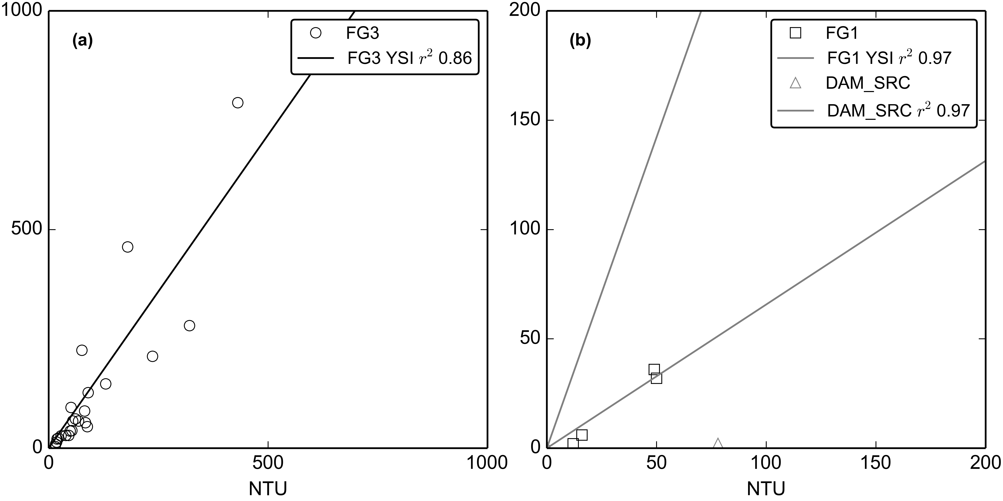

Figure 7. Turbidity-Suspended Sediment Concentration relationships for the YSI turbidimeter deployed at VILLAGE (02/27/2012-05/23/2012) and at FOREST (06/13/2013-12/31/2014).

The CampbellSci OBS500 measures both BS and SS, and both the BS-SSC and SS-SSC relationships at VILLAGE showed high r2 values (Figure 8 and Figure 9). Mean SS was used since it is physically measured the same as NTU measured by the YSI turbidimeter (Chauncey W. Anderson 2005).

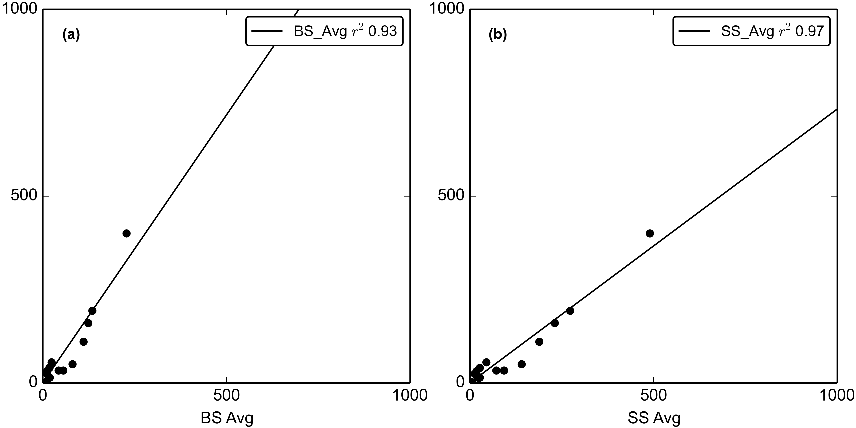

Figure 8. Turbidity-Suspended Sediment Concentration relationships for the OBS500 turbidimeter deployed at VILLAGE (03/11/2013-07/15/2013).

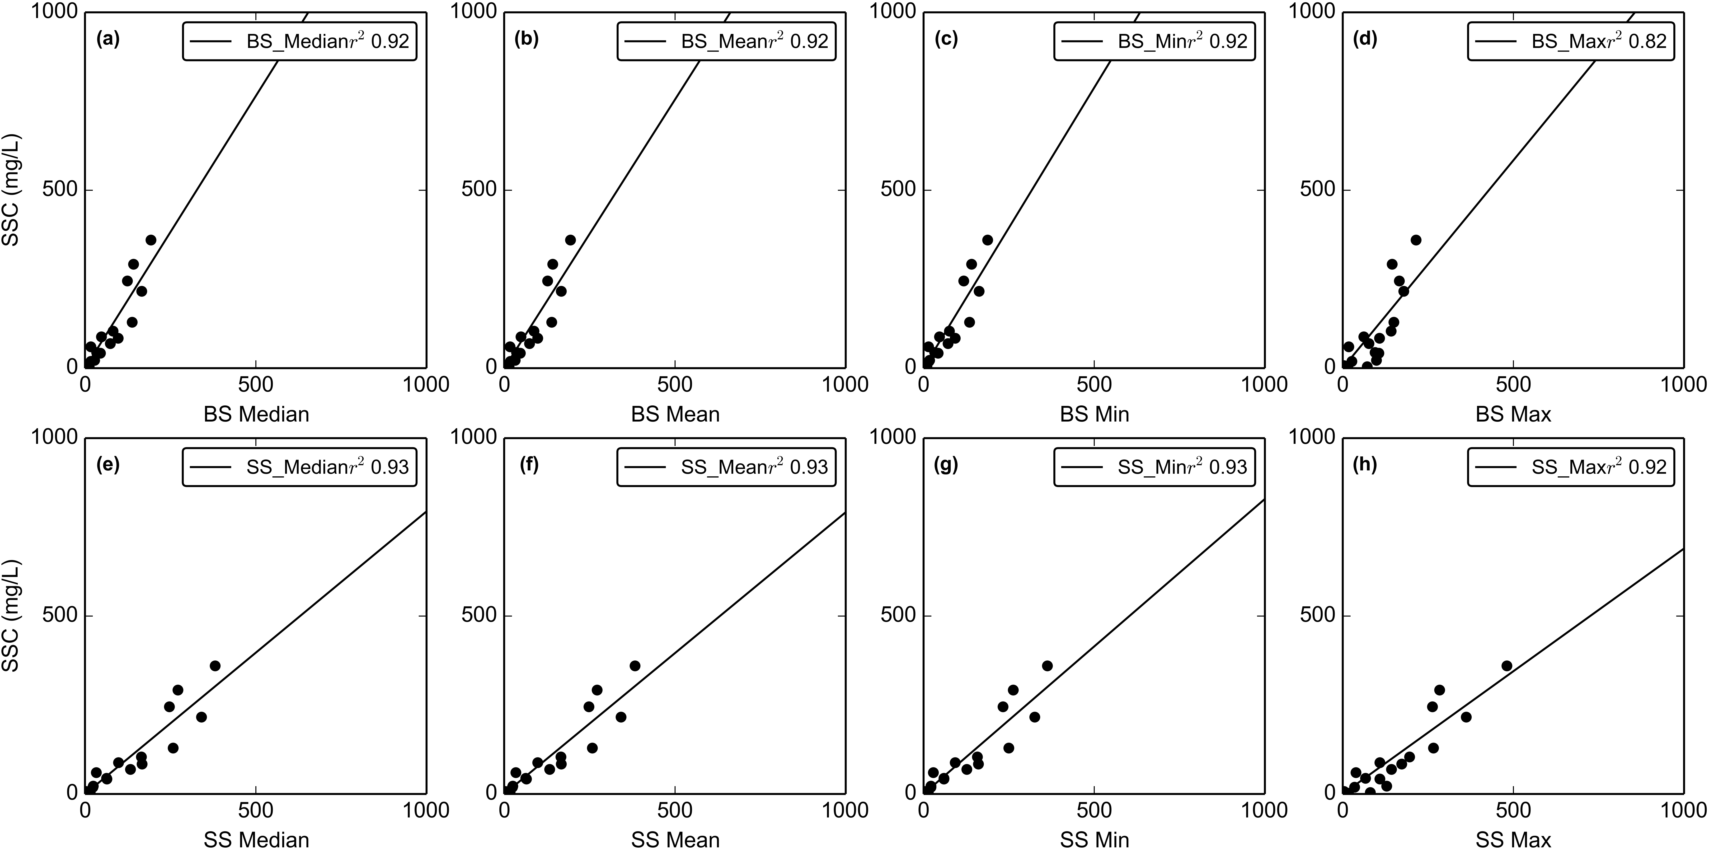

Figure 9. Turbidity-Suspended Sediment Concentration relationships for the OBS500 turbidimeter deployed at VILLAGE (01/31/2014-03/04/2014).

The RMSE for each selected T-SSC relationship was computed and used in the estimate of Probable Error. The RMSE for the T-SSC relationship was 5, 82, 25, 40 mg/L for the YSI at FOREST, YSI at VILLAGE, CampbellSci OBS500 at VILLAGE (2013), and CampbellSci OBS500 at VILLAGE (2014), respectively. The RMSE for YSI at FOREST was also used for the TS3000 at FOREST since the same T-SSC relationship was used.

### Storm Events

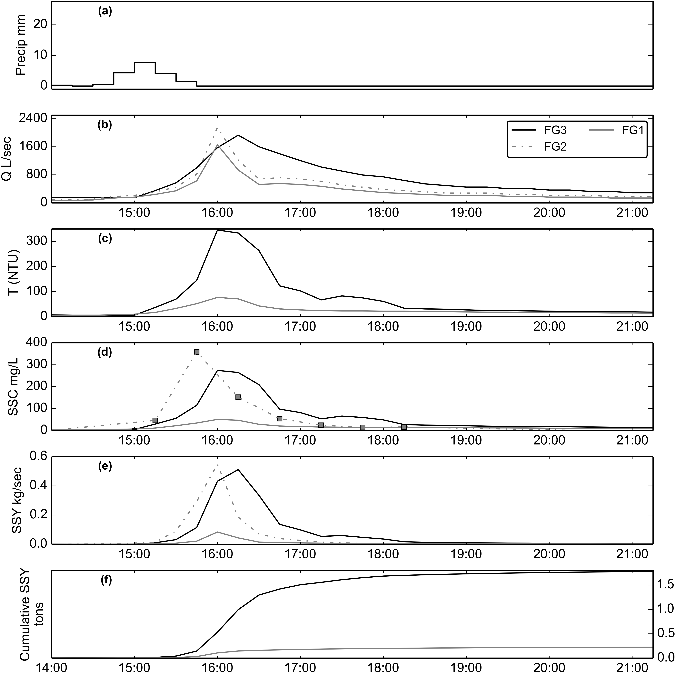

Figure 10. Example of storm event (02/14/2014) before sediment mitigation structures installed at quarry. SSY at FOREST and VILLAGE calculated from SSC modeled from T, and SSY at QUARRY from SSC samples collected by the Autosampler.

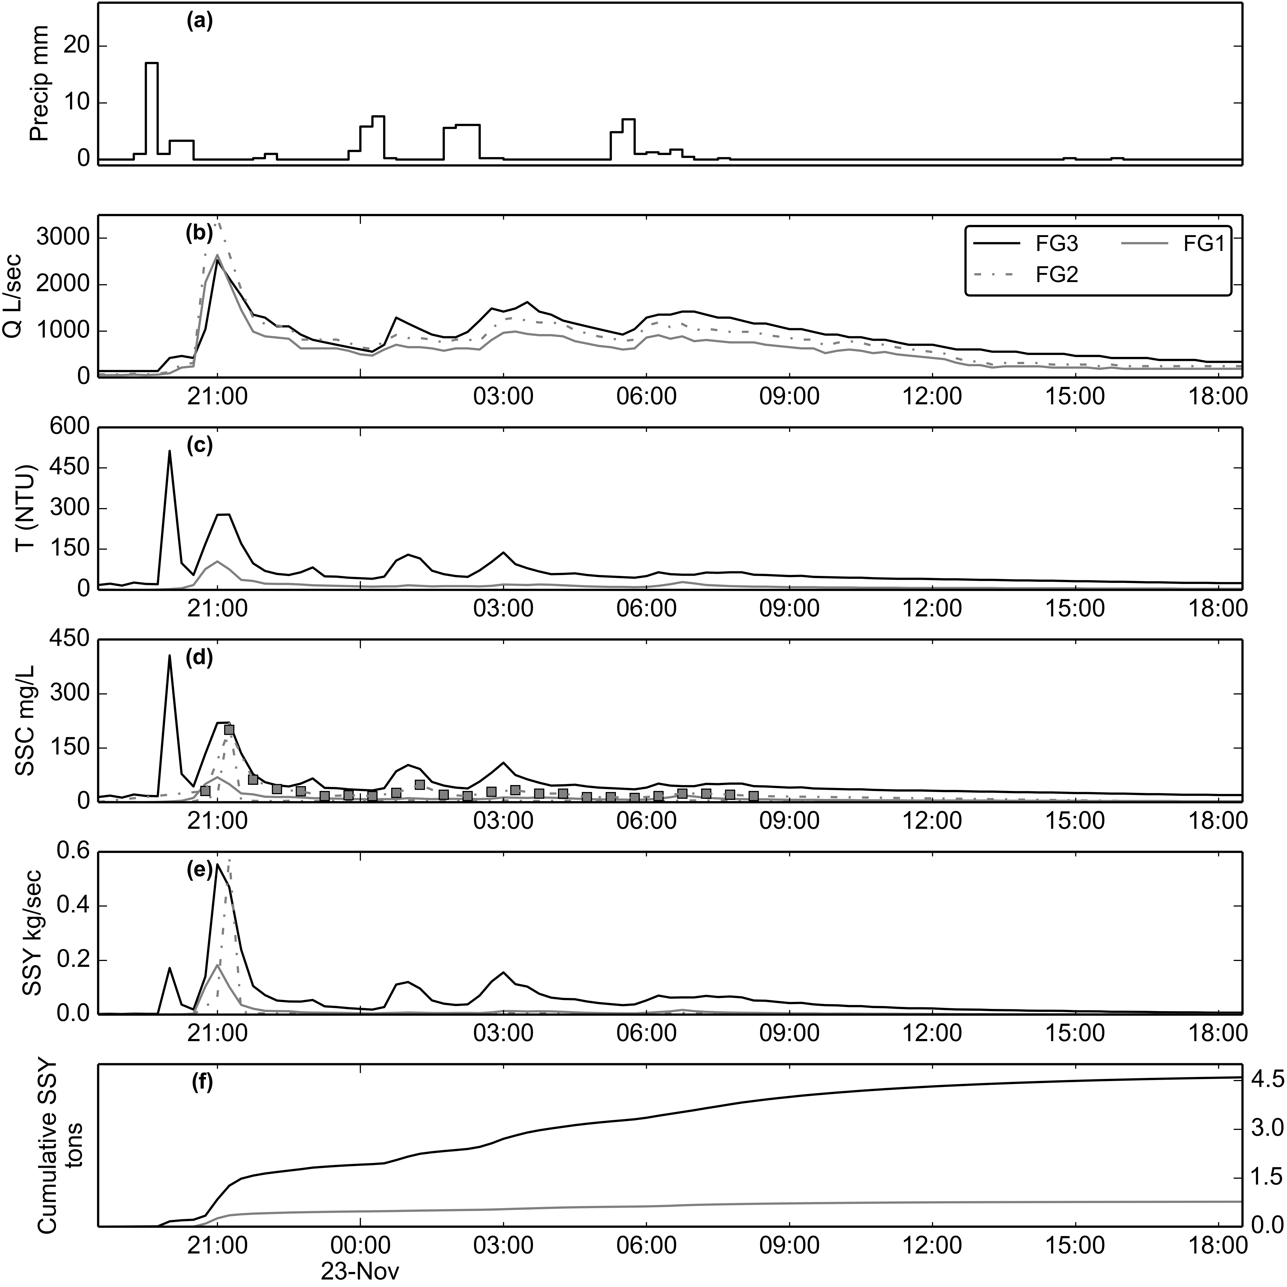

Figure 11. Example of storm event (11/22/2014) after sediment mitigation structures installed at quarry. SSY at FOREST and VILLAGE calculated from SSC modeled from T, and SSY at QUARRY from SSC samples collected by the Autosampler.

Using the stage threshold method and manual separation of complex storm events, 20 storm events were identified from Q data at VILLAGE from October, 2014, to January 2015. Valid Q data was recorded during 20 events at FOREST, and 15 events at VILLAGE . Valid SSC data from T and Interpolated Grab samples was recorded during 20 events at FOREST, and 14 events at VILLAGE. Of those storms, 20 events had valid P and SSY data for both the FOREST and VILLAGE to calculate and compare SSY from the UPPER and LOWER watersheds (Table 2). Valid SSY data from Interpolated grab samples was collected at QUARRY for 3 storms to compare with SSY from FOREST and VILLAGE directly (Table 3). Storm event durations ranged from 2 hours to 2 days, with mean duration of 13 hours.

### Comparing SSY from disturbed and undisturbed subwatersheds

The Upper and Lower subwatersheds are similar in size, 0.90km2 and 0.88km2, so assuming the specific SSY is similar in both watersheds, they should account for roughly the same percentage sediment contribution to the total. However, for the 3 storms with valid data from both FOREST and VILLAGE, SSY from the UPPER subwatershed (SSYUPPER) ranged from 3.0-94%, and accounted for an average of 24% of Total SSY. SSY from the Lower watershed (SSYLOWER) ranged from 5-96%, and accounted for an average of 76% of Total SSY (Table 2). This suggests that human disturbance in the Lower subwatershed has significantly increased Total SSY to Faga'alu Bay despite the relatively high amount of impervious surface associated with buildings and road surfaces in the village area.

|  |  |  |  |  |  |  |  |  |  |  |
| --- | --- | --- | --- | --- | --- | --- | --- | --- | --- | --- |
| Table 2. Sediment discharge from subwatersheds in Faga'alu | | | | | | | | | | |
| Storm Start | Storm# | Precip (mm) | UPPER tons | UPPER PE % | LOWER tons | TOTAL tons | SSY data source | TOTAL PE % | % UPPER | % LOWER |
| 10/15/2014 | 1 | 17 | 0.11 | 36 | 0.5 | 0.62 | T | 52 | 18.0 | 81.0 |
| 10/15/2014 | 2 | 17 | 0.19 | 36 | 0.33 | 0.52 | T | 52 | 36.0 | 63.0 |
| 11/02/2014 | 3 | 16 | 0.13 | 36 | 0.92 | 1.05 | T | 52 | 12.0 | 87.0 |
| 11/12/2014 | 4 | 1 | 0.01 | 36 | 0.24 | 0.25 | T | 52 | 3.0 | 96.0 |
| 11/12/2014 | 5 | 13 | 0.3 | 36 | 0.02 | 0.32 | T | 52 | 94.0 | 5.0 |
| 11/22/2014 | 6 | 78 | 0.77 | 36 | 3.79 | 4.56 | T | 52 | 16.0 | 83.0 |
| 11/24/2014 | 7 | 20 | 0.05 | 36 | 0.52 | 0.57 | T | 52 | 9.0 | 90.0 |
| 12/04/2014 | 8 | 65 | 0.26 | 36 | 1.45 | 1.71 | T | 52 | 15.0 | 84.0 |
| 12/09/2014 | 9 | 34 | 3.1 | 36 | 12.35 | 15.45 | T | 52 | 20.0 | 79.0 |
| 12/19/2014 | 10 | 62 | 1.1 | 36 | 2.16 | 3.26 | T | 52 | 33.0 | 66.0 |
| 12/21/2014 | 11 | 143 | 2.52 | 36 | 5.5 | 8.02 | T | 52 | 31.0 | 68.0 |
| Total/Avg: | 11 | 466 | 8.5 | 36 | 27.8 | 36.3 |  | 52 | 24 | 76 |
| Tons/km2 |  |  | 9.5 |  | 31.6 | 20.4 |  |  | - | - |
| DR |  |  | 1 |  | 3.3 | 2.2 |  |  | - | - |
| fraction disturbed (%) |  |  | 0.4 |  | 10.1 | 5.2 |  |  | - | - |
| SSY from forested areas (tons) |  |  | 8.5 |  | 7.5 | 16.0 |  |  | - | - |
| SSY from disturbed areas (tons) |  |  | 0.0 |  | 20.3 | 20.3 |  |  | - | - |
| % SSY from disturbed areas |  |  | 0.4 |  | 73 | 56 |  |  | - | - |
| sSSY from disturbed areas (tons/km2) |  |  | 9.5 |  | 228.1 | 219.5 |  |  | - | - |
| DR for sSSY from disturbed areas |  |  | - |  | 24 | 23 |  |  | - | - |

SSYEV data measured at FG2 was available for 3 of the storms in Table 2, so SSYEV from the LOWER subwatershed including the quarry (SSYLOWER_QUARRY) and the village areas below the quarry (SSYLOWER_VILLAGE) could be calculated to determine the relative sediment contribution from these sources (Table 3).

|  |  |  |  |  |  |  |  |  |  |
| --- | --- | --- | --- | --- | --- | --- | --- | --- | --- |
| Table 3. Sediment discharge from subwatersheds in Faga'alu | | | | | | | | | |
| Storm Start | Storm# | Precip (mm) | UPPER tons | LOWER_QUARRY tons | LOWER_VILLAGE tons | TOTAL tons | % UPPER | % LOWER_QUARRY | % LOWER_VILLAGE |
| 11/02/2014 | 1 | 16 | 0.13 | -0.05 | 0.97 | 1.05 | 12.0 | -4.0 | 92.0 |
| 11/12/2014 | 2 | 1 | 0.01 | -0.01 | 0.25 | 0.25 | 4.0 | -4.0 | 100.0 |
| 11/12/2014 | 3 | 13 | 0.3 | -0.3 | 0.32 | 0.32 | 93.0 | -93.0 | 100.0 |
| 11/16/2014 | 4 | 27 | 1.54 | -1.52 | 0.73 | 0.75 | 205.0 | -202.0 | 97.0 |
| 11/18/2014 | 5 | 5 | 0.79 | -0.79 | 0.17 | 0.17 | 464.0 | -464.0 | 100.0 |
| 11/19/2014 | 6 | 3 | 0.22 | -0.22 | 0.12 | 0.12 | 183.0 | -183.0 | 100.0 |
| 11/22/2014 | 7 | 78 | 0.77 | 0.03 | 3.76 | 4.56 | 16.0 | 0.0 | 82.0 |
| 11/24/2014 | 8 | 20 | 0.05 | 0.03 | 0.49 | 0.57 | 8.0 | 5.0 | 85.0 |
| 12/04/2014 | 9 | 65 | 0.26 | -0.2 | 1.65 | 1.71 | 15.0 | -11.0 | 96.0 |
| 12/09/2014 | 10 | 34 | 3.1 | -2.26 | 14.61 | 15.45 | 20.0 | -14.0 | 94.0 |
| 12/19/2014 | 11 | 62 | 1.1 | -0.8 | 2.96 | 3.26 | 33.0 | -24.0 | 90.0 |
| 12/21/2014 | 12 | 143 | 2.52 | -0.31 | 5.81 | 8.02 | 31.0 | -3.0 | 72.0 |
| Total/Avg: | 12 | 467 | 11 | -6 | 32 | 36 | 30 | -18 | 88 |
| Tons/km2 |  |  | 12 | -24 | 52 | 20 | - | - | - |
| DR |  |  | 1.0 | -1.98 | 4.4 | 1.7 | - | - | - |
| fraction disturbed (%) |  |  | 0.4 | 6.5 | 11.7 | 5.2 | - | - | - |
| SSY from forested areas (tons) |  |  | 10.7 | 3.0 | 6.5 | 20.2 | - | - | - |
| SSY from disturbed areas (tons) |  |  | 0.0 | -9.43 | 25.4 | 16.0 | - | - | - |
| % SSY from disturbed areas |  |  | 0.4 | 147 | 80 | 44 | - | - | - |
| sSSY from disturbed areas (tons/km2) |  |  | 12.0 | -537.1 | 355.6 | 172.9 | - | - | - |
| DR for sSSY from disturbed areas |  |  |  | -44.8 | 29.7 | 14.4 | - | - | - |

For the measured storms in Table 3, TOTAL SSY was 36 tons, comprised of an average of 30% from the UPPER subwatershed, -18% from LOWER_QUARRY subwatershed, and 88% from the LOWER_VILLAGE subwatershed. sSSY from the UPPER, LOWER_QUARRY, and LOWER_VILLAGE subwatersheds and TOTAL watershed was 12, -24, 52, and 20, respectively. sSSY from LOWER_QUARRY and LOWER_VILLAGE was -1.98 and 4.4 times higher, respectively, than sSSY from UPPER subwatershed, suggesting human disturbance has significantly increased SSY over natural levels, particularly at the quarry. sSSY from the TOTAL watershed was 1.7 times higher than the UPPER subwatershed, similar to the larger range of storms in Table 2, where specific SSY was 2.2 times higher.

### Predicting SSYEV from storm metrics

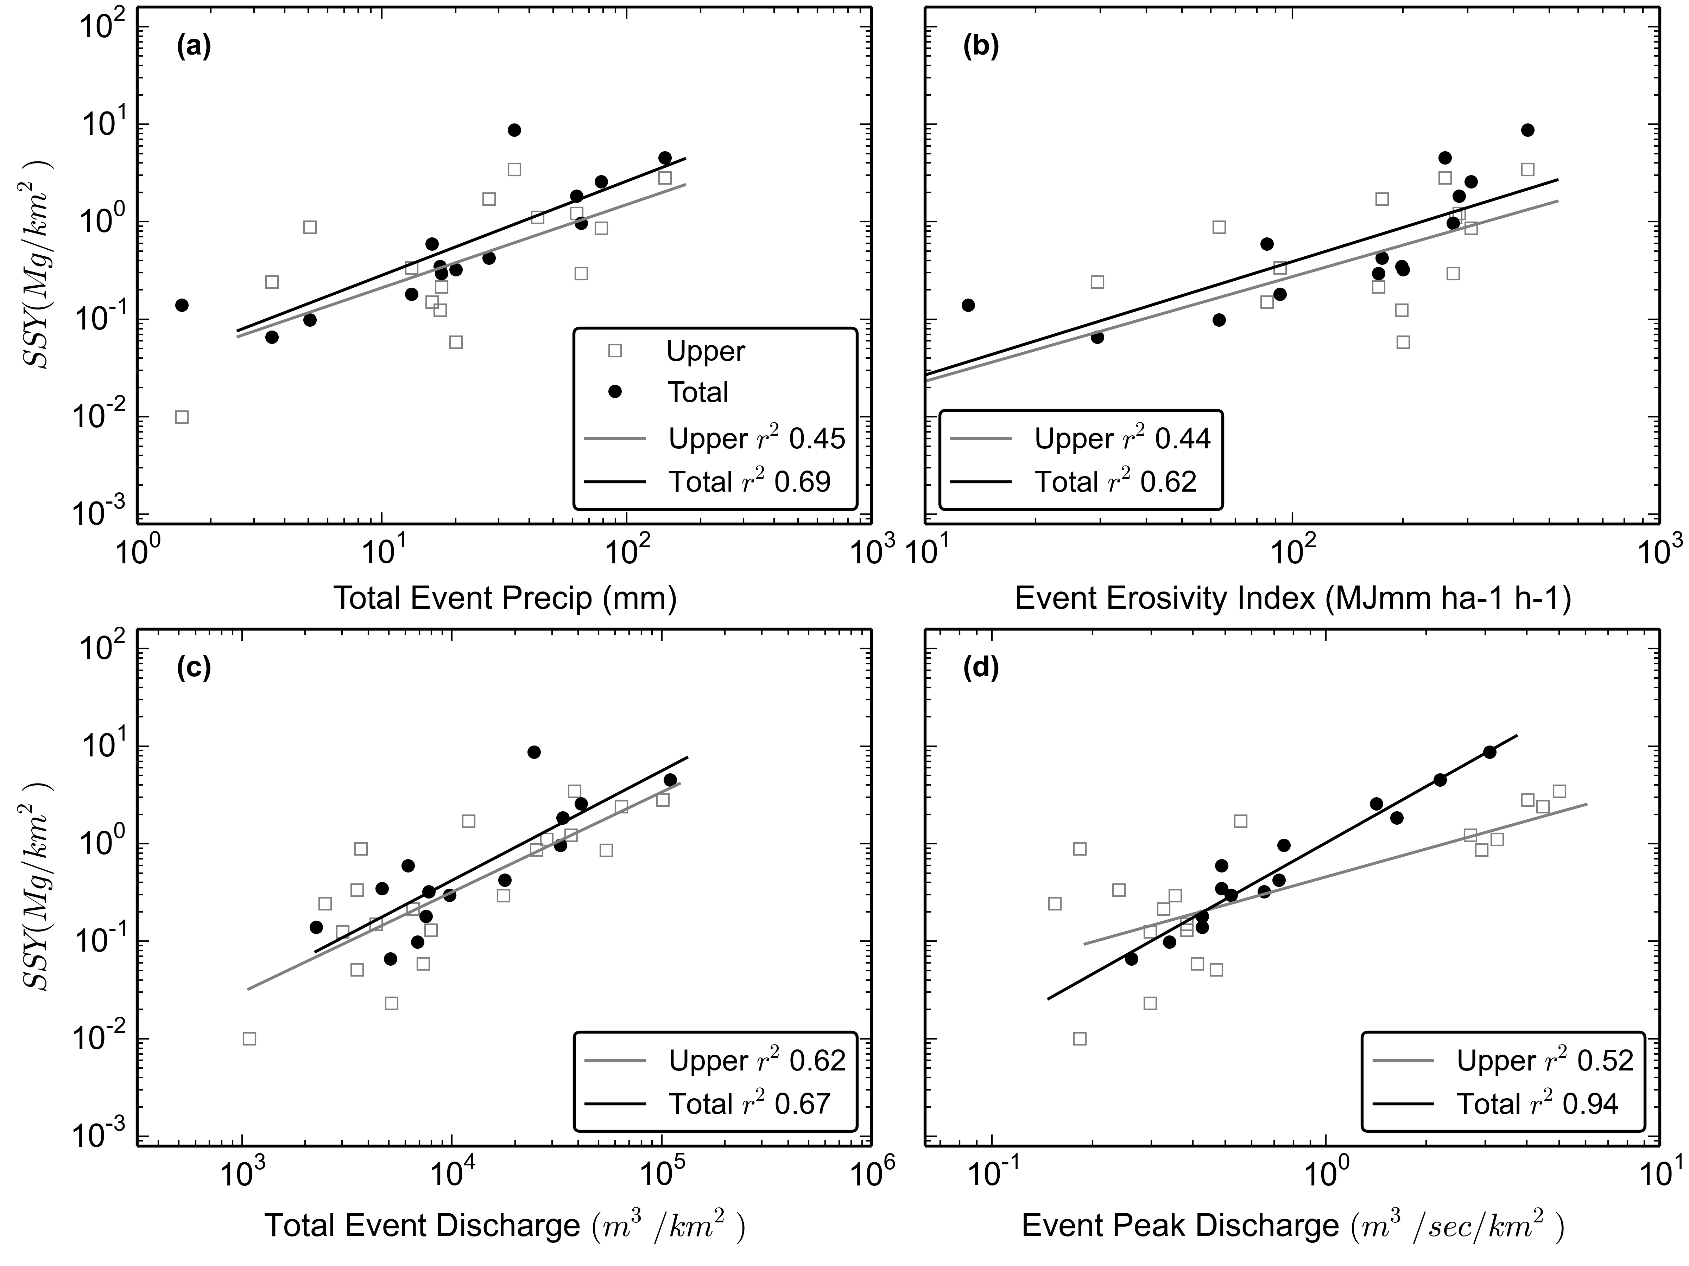

Figure 12. SSY rating curves for predictors

|  |  |  |  |  |  |  |
| --- | --- | --- | --- | --- | --- | --- |
| Table 4. Model statistics | | | | | | |
| Model | Pearson | Spearman | r2 | RMSE(tons) | alpha | Beta |
| Psum_upper | - | - | 0.45 | 3.35 | 0.027 | 0.85 |
| Psum_total | 0.83 | 0.88 | 0.69 | 2.33 | 0.054 | 0.97 |
| EI_upper | - | - | 0.44 | 3.38 | 0.002 | 1.07 |
| EI_total | 0.78 | 0.88 | 0.62 | 2.57 | 0.003 | 1.16 |
| Qsum_upper | 0.79 | 0.74 | 0.62 | 2.81 | 0.000 | 1.03 |
| Qsum_total | 0.82 | - | 0.67 | 2.39 | 0.000 | 1.12 |
| Qmax_upper | 0.72 | - | 0.52 | 3.21 | 0.454 | 0.95 |
| Qmax_total | 0.97 | 0.94 | 0.94 | 1.45 | 0.598 | 1.92 |

## Conclusion

## APPENDIX